Chapter 3, Solution 29

At node 1,
(1)
At node 2,
(2)
At node 3,
(3)
At node 4,
(4)
In matrix form, (1) to (4) become
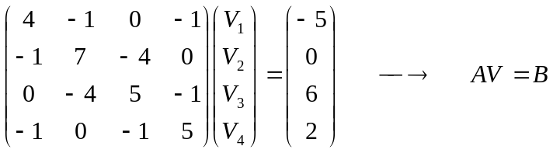
Using MATLAB,

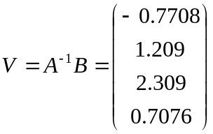
i.e.

